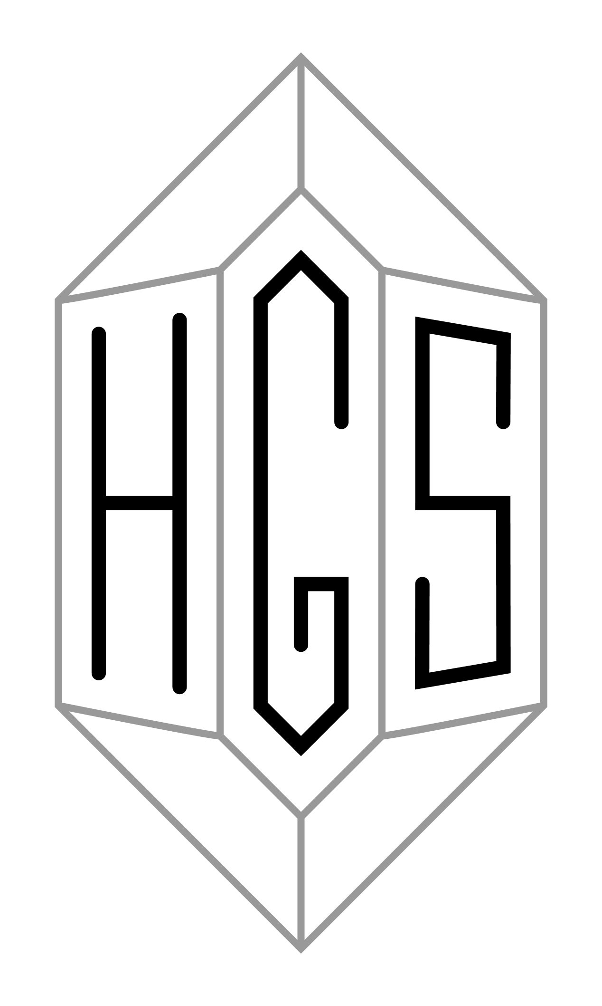 | THE HIGHLAND GEOLOGICAL SOCIETY  Scottish Charity No. SC004427

March 2021

Dear Members,

We hope everyone is keeping well and that you have enjoyed our winter season of interesting talks. This newsletter is being written with beautiful spring sunshine coming through the window, and even the rocks are beginning to warm up!

We still have two Zoom talks to come in the next two months to be delivered by guest lecturers, and we are being given access to a third talk in London. We are actively looking into holding shorter (say 20 minutes) virtual field trip talks to be delivered by HGS members in the following months.

Also, as a reminder, HGS members are invited to view Edinburgh, Glasgow and Aberdeen Geological Society talks. The Edinburgh and Glasgow ones are listed on their respective websites, and we are being sent invitations to the Aberdeen ones as and when they occur.

With slowly improving news about COVID-19, we may yet be able to see some geology in small informal groups over the summer months but we don’t have any official HGS trips currently planned.

Lectures

Our next talk will be run in conjunction with the Aberdeen Geological Society. The details are:

Thurs 18th March 2021: The Dating Game: One Man’s Search for the Age of the Earth, Dr Cherry Lewis, Honorary Research Fellow, School of Earth Sciences, University of Bristol.

“How old is the Earth? At the end of the nineteenth century, geologists, biologists, physicists and astronomers were all looking for a clock that would provide an answer to this, the greatest Time question of all. The Dating Game tells the story of one man's vision of developing a geological timescale that would finally lead to an accurate date for the Age of the Earth. Despite scientific opposition, financial hardship and personal tragedy, Arthur Holmes (1890-1965), greatest geologist of the twentieth century, fought for fifty years to convince the establishment of an Earth of great antiquity: a fight which eventually transformed the moribund 'art' of geology into a dynamic science. This talk will bring Holmes back to life and weave his adventures, loves and losses around the discovery of radioactivity – the clock that tells geological time – and the early science of dating the Earth”.

The usual Zoom joining details will be sent out shortly before the event. This will start at 7.30 pm.

Wed 14th April 2021: Stac Fada impact deposit: Dr Ken Amor, Stipendiary Lecturer in Geography and Researcher, Department of Earth Sciences, University of Oxford.

Through the good offices of Andy Moffat we are going to be able to hear this talk by Dr Ken Amor to be given at the Geological Society’s Discussion Group on Wednesday 14th April 2021 at 6.30 pm for 7.00 pm. Members may recall that Dr Amor was one of the authors of the article published in 2008 and entitled “A Precambrian proximal ejecta blanket from Scotland” which proposed in short that the deposit, rather than being volcanic in origin, had been caused by a meteorite impact – see https://www.ox.ac.uk/news-and-events/find-an-expert/dr-ken-amor.

It is understood that we shall be in a position to send out the Zoom joining details to members a day or two before the event at the latest. The event opens at 6.30 pm but the talk itself begins at 7.00 pm and is followed by the usual Q & A session. HGS Members are asked to ensure that their microphones are muted throughout the event.

Wed 21st April 2021: Dawn of the Modern World: Life, Death and Rain in the late Triassic: Dr Mike Simms, National Museums Northern Ireland.

“In October 1987 Alastair Ruffell and I stumbled across evidence that a major climate change event 230 million years ago was seemingly linked to a mass extinction. The “Carnian Pluvial Episode”, as we christened it, is now studied by research groups around the world and is known to be linked to the diversification of many elements of modern ecosystems, from dinosaurs to dinoflagellates, and coccoliths to coral reefs. Without this, our modern world might be very different. Hear the story of its discovery and subsequent investigation from one of those that actually discovered it, and what the latest research might imply for current climate change”.

Members may recall that Dr Simms gave a talk on the Stac Fada impact deposit at the Rock Stop in 2019 and then led a trip to the Stac Fada exposure at Stoer the following day. He contacted us recently and very kindly offered to give this talk.

This talk is an addition to our winter programme of talks. It will take place at 7.30 pm, and the Zoom joining instructions will be sent out by Alan Thompson shortly before in the usual way.

Summer programme

Stack of Glencoul and Shetland

The excursion to the Stack of Glencoul, which we had hoped would take place in the early part of this summer, will not be going ahead. It may be possible to rearrange it for a later date this summer or possibly even in 2022. But that remains to be seen.

As those of you who were present at the AGM will have heard, unfortunately we are also having to abandon the Shetland trip, at least for this summer, as the hostel at Saxa Vord on Unst where we had booked to stay will not be opening this year.

Virtual Field Trips – Can you help?

At their meeting on 15th February 2021 the committee discussed what we should do in the way of organising field trips this summer. In a nutshell, the position remains the same as indicated in the December newsletter, namely that for the time being we are not going to organise any “live” field trips. Instead, we are hoping to arrange a series of virtual field trips (VFTs), as we did last summer.

In order to do these VFTs we need more material. Subject to the COVID-19 restrictions we plan to get out for a series of small (3 or 4 people?) recces to places of interest, explore, take photographs, and if suitable prepare a short (say 20 minutes) VFT. We can then in the summer hold Zoom meetings, including two or three such short VFTs, similar to the members’ evenings organised by other societies.

We have had some suggestions from committee members which they will follow up. We hope that other members of the Society will be willing to contribute as well. It may be that you have existing material, including photographs, which may be suitable, or you may have suggestions for the committee, or you may be able to organise a small group recce to gather or develop material. If you have any suggestions and/or would like to contribute, please contact Anne Cockroft at hgssec@gmail com.

In some cases, it is hoped that these VFTs may, after COVID-19, form the basis of a real field trip.

Miscellaneous

Following his talk after the AGM, Professor Rob Strachan has sent us copies of sixteen learned articles published since 2007. These articles focus, very broadly, on the metamorphic rocks of Shetland of which he spoke during his talk. He has very kindly agreed that we may distribute these to members, and also the field guide prepared by himself and two others for the Metamorphic Studies Group’s excursion to Shetland in 2015. If anyone would like copies of any of these, would he or she please contact Anne Cockroft at hgssec@gmail.com? (It is perhaps worth mentioning that Professor Strachan plans to update the field guide later this year, so if you want to see a copy it might be worth waiting until this has been done).

Members may recall the talk given last October by Professor Frank Rennie on the geology and landscape of Lewis. His book: The Changing Outer Hebrides – Galson and the meaning of Place was published by Acair in 2020, ISBN: 9781789070835 – see https://www.acairbooks.com/categories/non-fiction-titles/all-non-fiction/the-changing-outer-hebrides.aspx.

Sinclair Ross archive

As many of you will know, Sinclair, an HGS founder member and president for many years, sadly passed away in 2013. Recently we have been investigating his collection of field notes and a small committee comprising Ann and Peter Reynolds, Alison Wright and Dave Longstaff will look towards cataloguing his papers for research purposes. The notes could give ideas with a view to putting together field trips, local to Inverness and Moray, which might be an option for group activities in the future.

Items of interest, geological websites, online resources

The NW Highlands Geopark recently hosted an excellent talk by Dr Fankie Dunn on Cambrian fossils and they have more talks lined up over the next few months with the mapping of the NW Highlands as a central theme.
https://www.nwhgeopark.com/

This last year has seen many geology lectures recorded for viewing. Here is a link to the Angus Miller “Geowalks” website which has 21 talks on Scottish geology for viewing and they’re all recommended. There are several talks on Mull (James Westland) and Islay (David Webster) and also talks by Elsa Panciroli (Eigg dinosaur) and Katie Strang (Fife fossils) amongst others.
https://www.geowalks.co.uk/geology-talks/

The Geologist’s Association has put together an exhaustive list of resources:
https://geologistsassociation.org.uk/sofageology/

Geological Society lectures and library:-
https://www.geolsoc.org.uk/Library-and-Information-Services/Virtual-Library/additional-online-resources-covid-19

Palaeocast podcasts:-
https://www.palaeocast.com/category/mesozoic/

The Scottish Geology Trust’s website has a range of interesting material including a selection of past talks by James Westland, Elsa Panciroli and Katie Strang and others.
http://www.scottishgeologytrust.org/

Other Scottish geological societies’ websites:

Aberdeen Geological Society
http://www.aberdeengeolsoc.org.uk/

Edinburgh Geological Society
https://www.edinburghgeolsoc.org/

Glasgow Geological Society
https://geologyglasgow.org.uk/

Open University Geology Society
https://ougs.org/

CONTACT INFORMATION:
Chairman: Stephen Young 01349 864141 sstyoung84@gmail.com
Secretary: Anne Cockroft 01463 238992 hgssec@gmail.com
Treasurer: Alan Thompson 01463 238992 alanrossthompson@hotmail.com

